You can access the Emergency Information section two different ways, along the top or on the left side (as shown below):
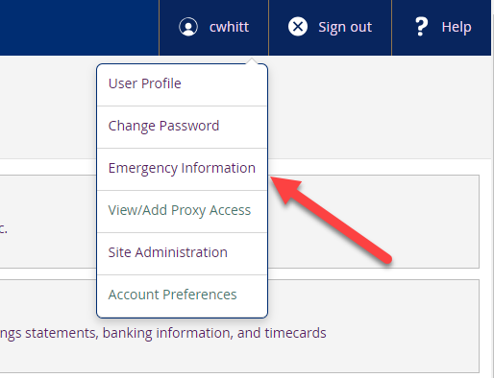 Or 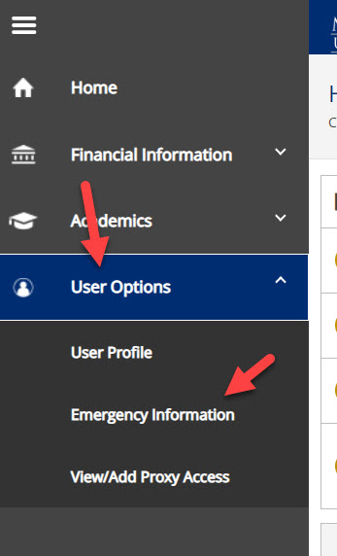
Fill in boxes 1-3 as shown, then submit by clicking button shown at #4 and then confirm as shown at #5. 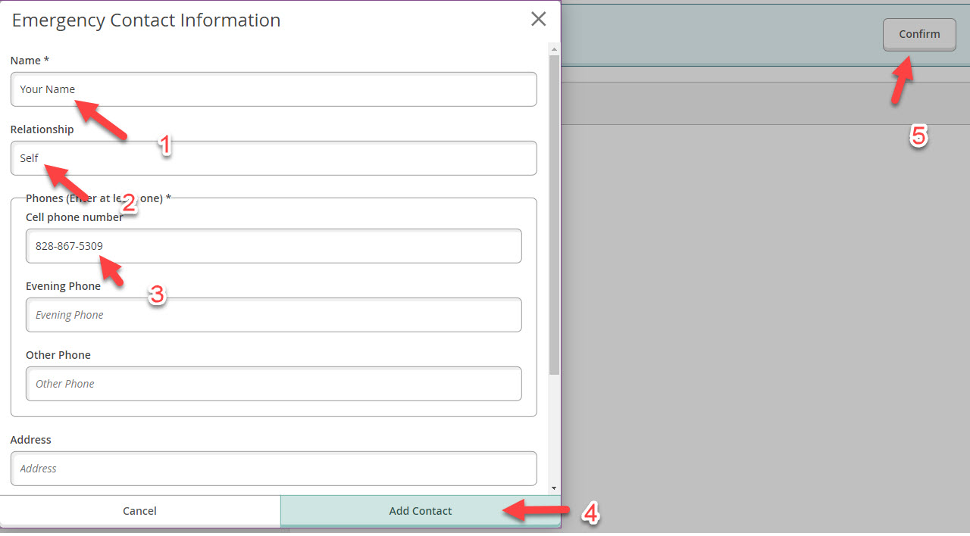
Information may be edited as needed by going back into your emergency contact screen and clicking on the pencil icon. Make changes then “Update Contact” and “Confirm”. This should be done whenever you get a new cell phone number. Other emergency contact numbers may be added but the contact entitled “self” will be the one used for emergency notifications.
