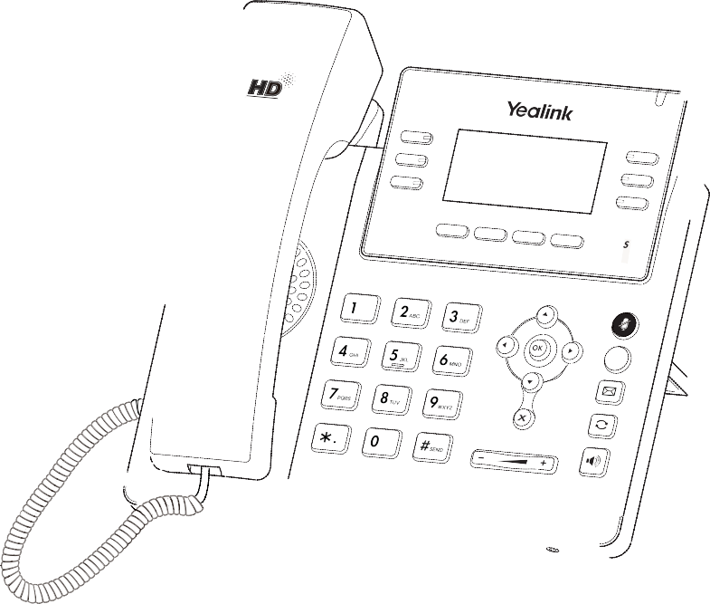

Quick Start Guide (V82.20)

www.yealink.com
Ultra-elegant Gigabit IP Phone

Applies to firmware version 66.82.0.10 or later.

Basic Call Features

Placing a Call Using the handset:
- Pick up the handset.
- Enter the number, and then press the Send soft key.

Using the speakerphone:
- With the handset on-hook, press .
- Enter the number, and then press the Send soft key.

Using the headset:
- With the headset connected, press to activate the headset mode.
- Enter the number, and then press the Send soft key.

Note: During a call, you can alternate between the headset, hands-free speakerphone and handset modes by pressing the Headset key, the Speakerphone key or by picking up the handset. Headset mode requires a connected headset.
Answering a Call Using the handset: Pick up the handset.

Using the speakerphone:
Press .

Using the headset:
Press .

Note: You can reject an incoming call by pressing the Reject soft key.

Ending a Call Using the handset:
Hang up the handset or press the End Call soft key.

Using the speakerphone:
Press or the End Call soft key.

Using the headset:
Press the End Call soft key.

Redial

Press to enter the placed call list, press or to select the desired entry, and then press or the Send soft key.

Press twice when the phone is idle to dial out the last dialed number.

Call Mute and Un-mute
Press to mute the microphone during a call. Press again to un-mute the call.

Call Hold and Resume To place a call on hold:
Press the Hold soft key during an active call.

To resume the call, do one of the following:
If there is only one call on hold, press the Resume soft key.

If there is more than one call on hold, press or to select the desired call, and then press the
Resume soft key.

Call Transfer
You can transfer a call in the following ways:

Blind Transfer
- Press the Transfer soft key during an active call. The call is placed on hold.
- Enter the number you want to transfer to.
- Press the B Trans soft key.

Semi-Attended Transfer
- Press the Transfer soft key during an active call. The call is placed on hold.
- Enter the number you want to transfer to, and then press the Send soft key.
- Press the Transfer soft key when you hear the ring-back tone.

Attended Transfer
- Press the Transfer soft key during an active call. The call is placed on hold.
- Enter the number you want to transfer to, and then press the Send soft key.
- Press the Transfer soft key when the second party answers.

Call Forward
To enable call forward:
- Press the Menu soft key when the phone is idle, and then select Features->Call Forward.
- Select the desired forward type:
Always Forward----Incoming calls are forwarded unconditionally.
Busy Forward----Incoming calls are forwarded when the phone is busy.
No Answer Forward----Incoming calls are forwarded if not answered after a period of time.
- Enter the number you want to forward to. For No Answer Forward, press or to select the desired ring time to wait before forwarding from the After Ring Time field.
- Press the Save soft key to accept the change.

Call Conference
- Press the Conf soft key during an active call. The call is placed on hold.
- Enter the number of the second party, and then press the Send soft key.
- Press the Conf soft key again when the second party answers. All parties are now joined in the conference.
- Press the End Call soft key to disconnect all parties.
Note: You can split the conference call into two individual calls by pressing the Split soft key.

Speed Dial
To configure a speed dial key:
- Press the Menu soft key when the phone is idle, and then select Features->DSS Keys.
- Select the desired DSS key, and then press the Enter soft key.
- Select SpeedDial from the Type field, select the desired line from the Account ID field, enter a label in the
Label field and then enter the number in the Value field.
- Press the Save soft key to accept the change.

To use the speed dial key:
Press the speed dial key to dial out the preset number.

Voice Message
Message waiting indicator on the idle screen indicates that one or more voice messages are waiting at the message center. The power indicator LED slowly flashes red.

To listen to voice messages:
- Press or the Connect soft key.
- Follow the voice prompts to listen to your voice messages.

Customizing Your Phone

Call History
- Press the History soft key when the phone is idle, press or to scroll through the list.
- Select an entry from the list, you can do the following: Press the Send soft key to call the entry.
Press the Delete soft key to delete the entry from the list.
If you press the Option soft key, you can also do the following: Select Detail to view detailed information about the entry. Select Add to Contact to add the entry to the local directory.
Select Add to Blacklist to add the entry to the blacklist. Select Delete All to delete all entries from the list.

Contact Directory To add a contact:
- Press the Directory soft key when the phone is idle, and then select All Contacts.
- Press the Add soft key to add a contact.
- Enter a unique contact name in the Name field and contact numbers in the corresponding fields.
- Press the Add soft key to accept the change.

To edit a contact:
- Press the Directory soft key when the phone is idle, and then select All Contacts.
- Press or to select the desired contact, press the Option soft key and then select Detail from the prompt list.
- Edit the contact information.
- Press the Save soft key to accept the change.

To delete a contact:
- Press the Directory soft key when the phone is idle, and then select All Contacts.
- Press or to select the desired contact, press the Option soft key and then select Delete from the prompt list.
- Press the OK soft key when the LCD screen prompts “Delete selected item?”.
Note: You can add contacts from call history easily. For more information, refer to Call History above.

Volume Adjustment
Press during a call to adjust the receiver volume of the handset/speakerphone/headset. Press when the phone is idle or ringing to adjust the ringer volume.
Press to adjust the media volume in the corresponding screen.

Ring Tones
- Press the Menu soft key when the phone is idle, and then select Settings->Basic Settings->Sound-> Ring Tones.
- Press or to select Common or the desired account and then press the Enter soft key.
- Press or to select the desired ring tone.
- Press the Save soft key to accept the change.

About Yealink
Yealink (Stock Code: 300628) is a global leading unified communication (UC) terminal solution provider that primarily offers video conferencing systems and voice communication solutions. Founded in 2001, Yealink leverages its independent research and development and innovation to pursue its core mission: “Easy collaboration, high productivity.” The company’s high-quality UC terminal solutions enhance the work efficiency and competitive advantages of its customers in over 100 countries. Yealink is the world’s second-largest SIP phone provider and is number one in the China market.

Technical Support
Visit Yealink WIKI (http://support.yealink.com/) for the latest firmware, guides, FAQ, Product documents, and more. For better service, we sincerely recommend you to use Yealink Ticketing system (https://ticket.yealink.com) to submit all your technical issues.

T 4 2 S- E N
YEALINK(XIAMEN) NETWORK TECHNOLOGY CO.,LTD.
Web: www.yealink.com
Addr: 309, 3th Floor, No.16, Yun Ding North Road, Huli District, Xiamen City, Fujian, P.R. China
Copyright©2017 YEALINK(XIAMEN) NETWORK
TECHNOLOGY CO.,LTD.All rights reserved.

